***Assignment -4***

***Andrew John***

***18BEC1278***

* **Develop a mobile application that takes the user input and sends it to an IoT device (python code). print the received data in python shell. Keep a text box to accept the user input.integrate a submit button. Whenever a user enters the text input in the text box and clicks the button the data should be sent to IBM cloud using URL (HTTP API).**

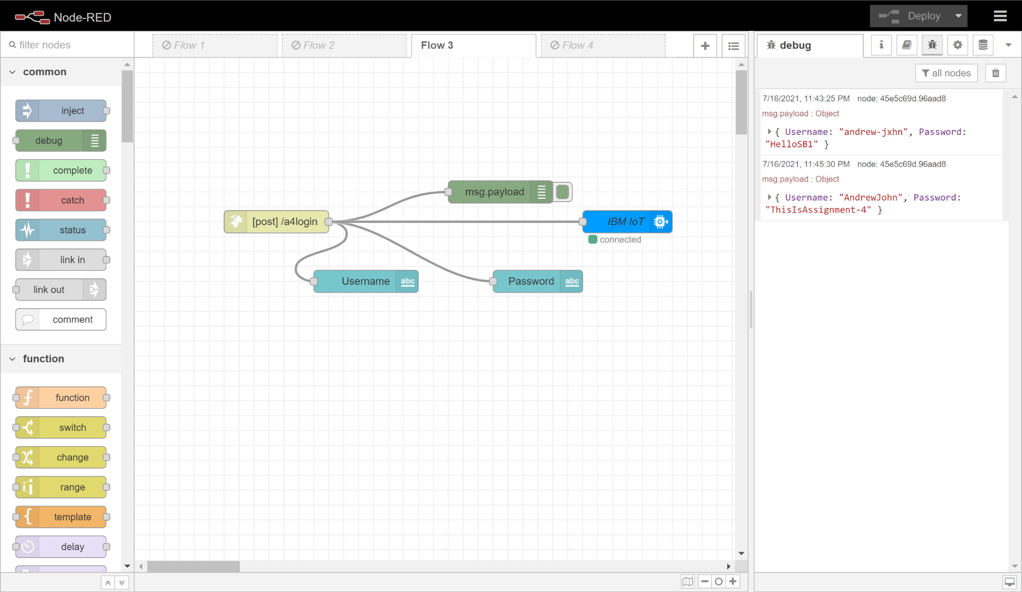

*Fig-1: Node-RED Flow*

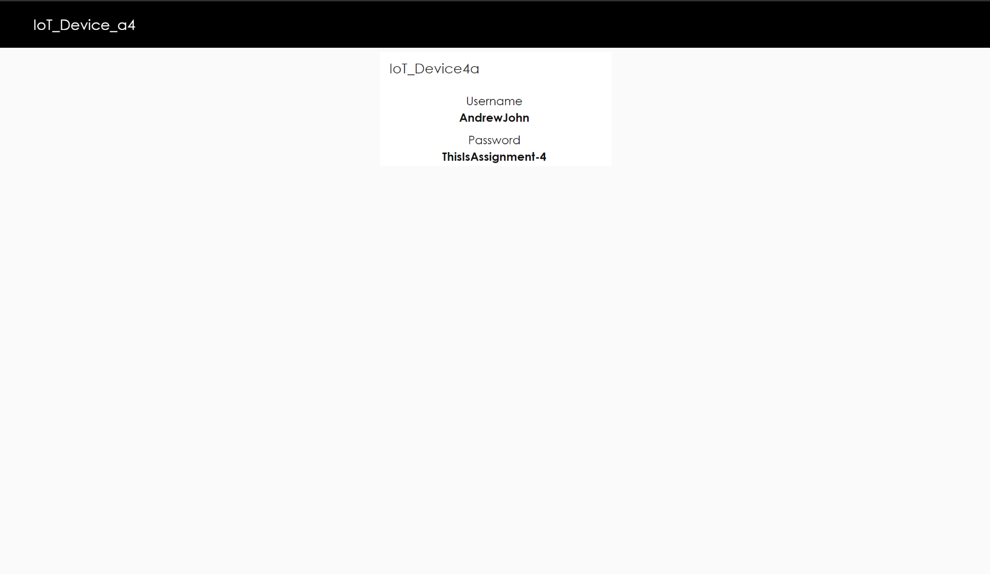

*Fig-2: Node-RED UI Dashboard*

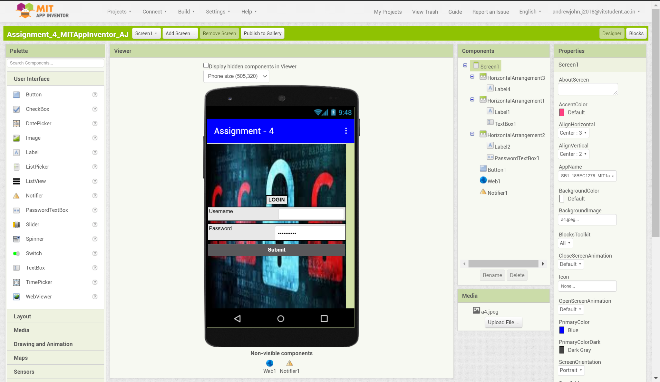

*Fig-3: MIT App Inventor Designer*

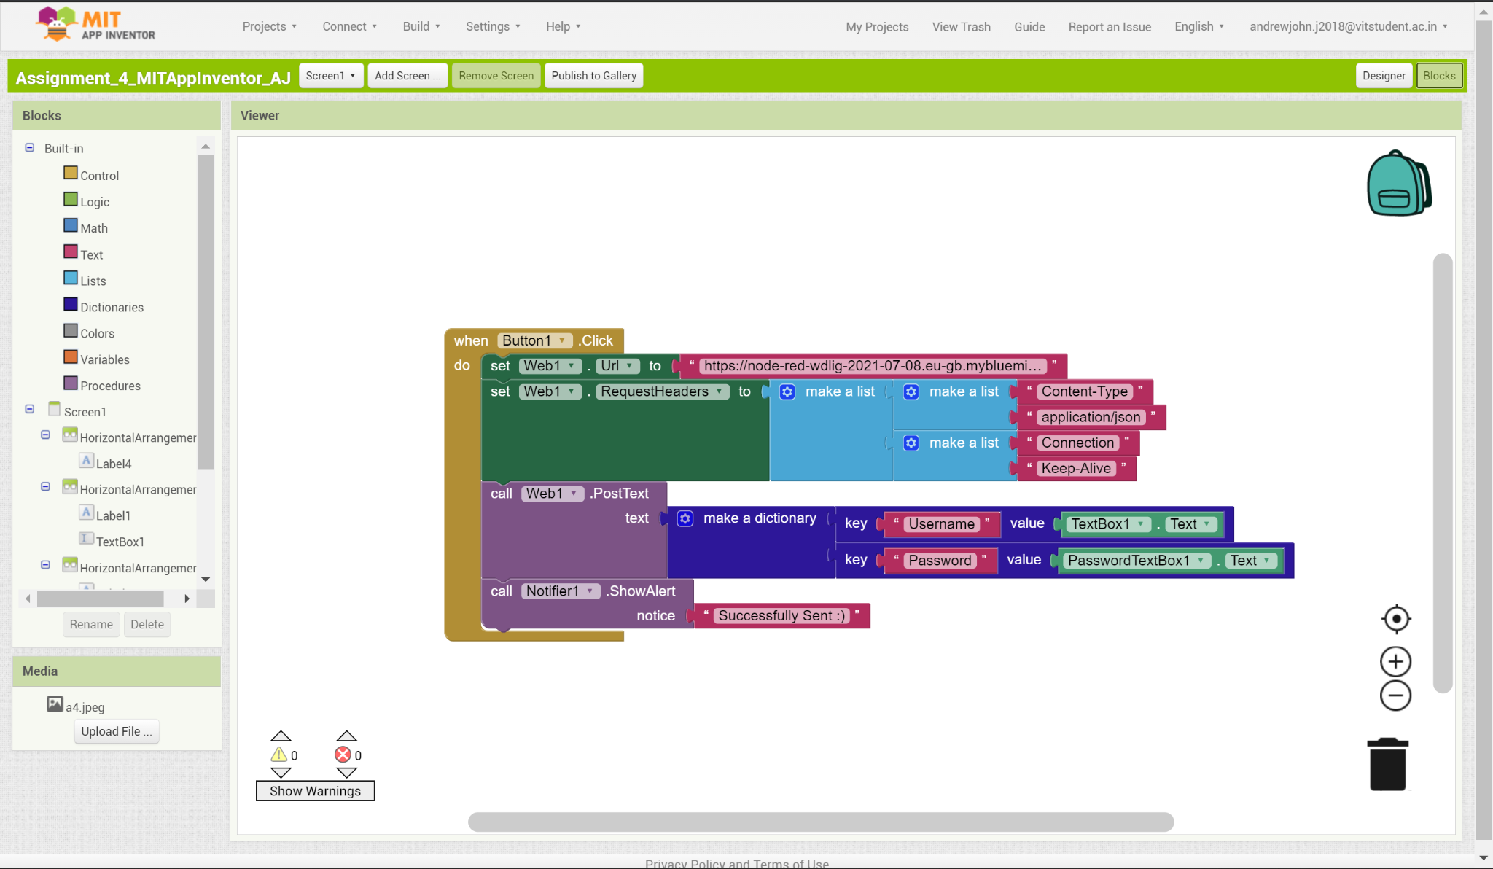

*Fig-4: MIT App Inventor Blocks*

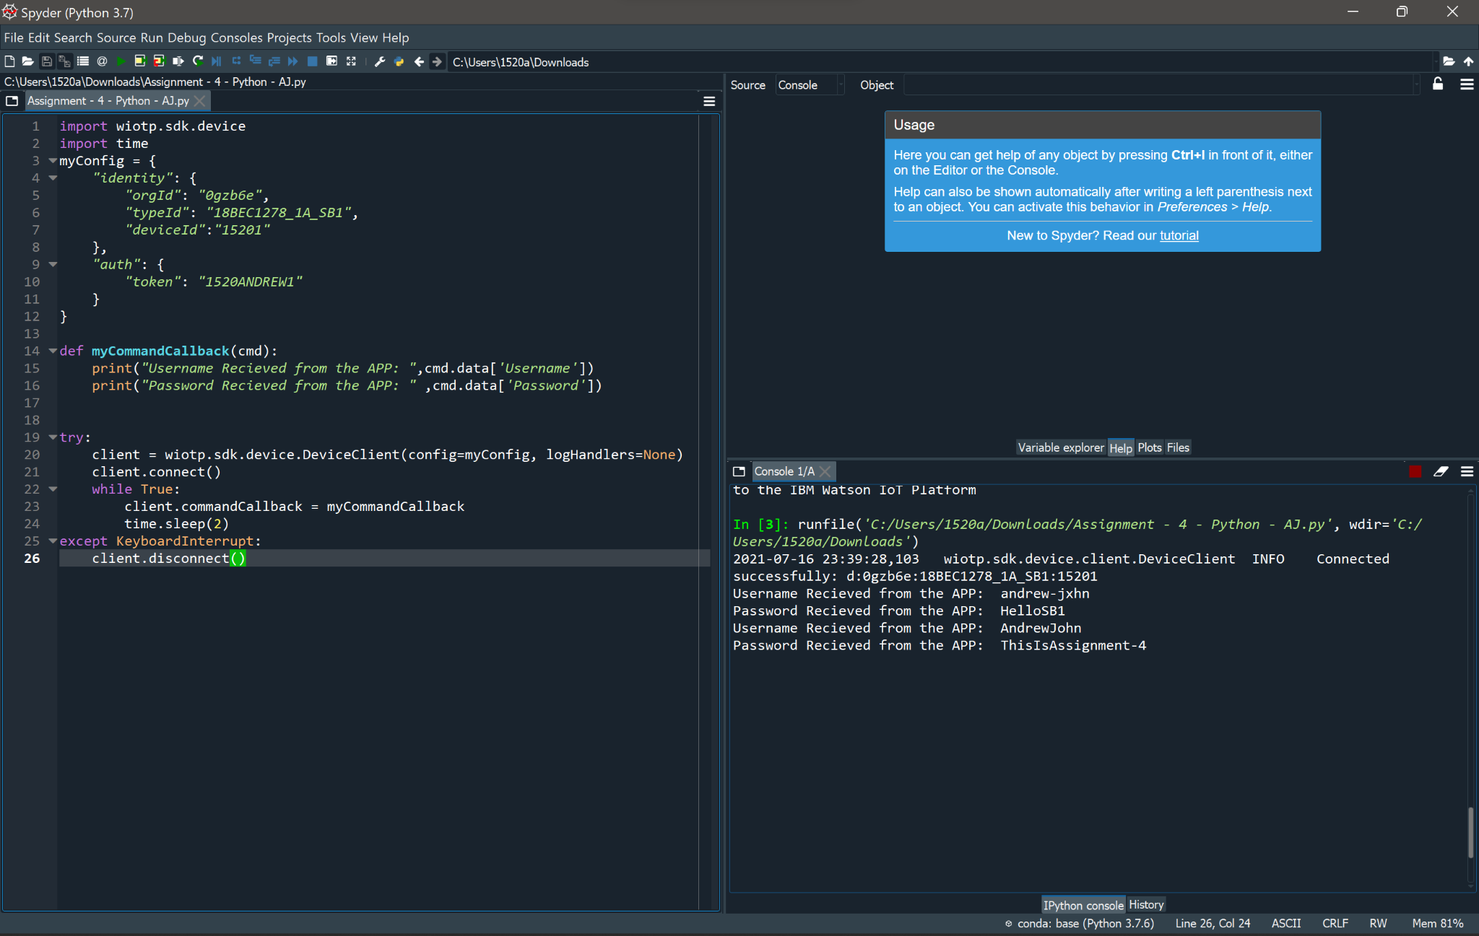

*Fig-5: Python Code*

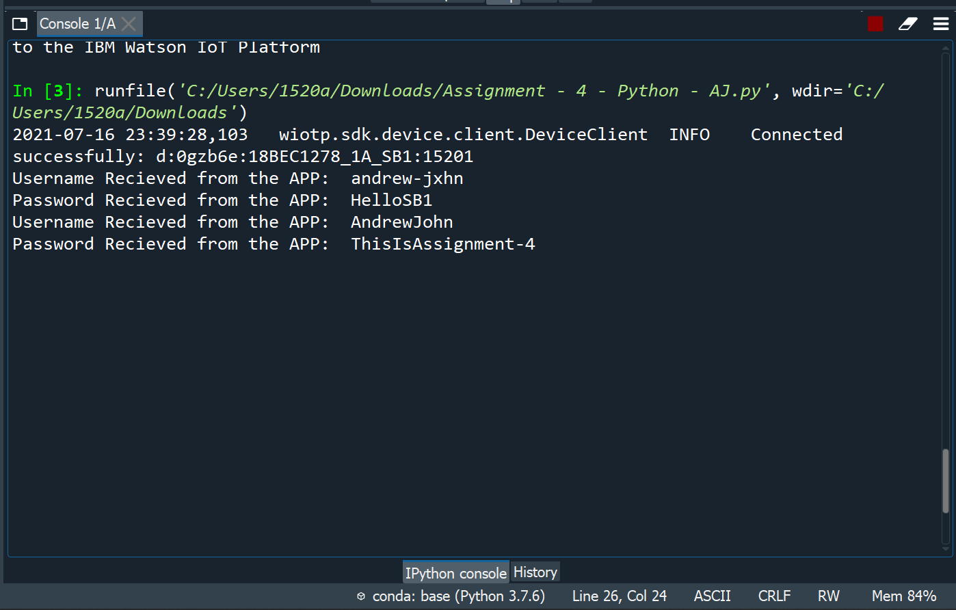

*Fig-6: Python Console*

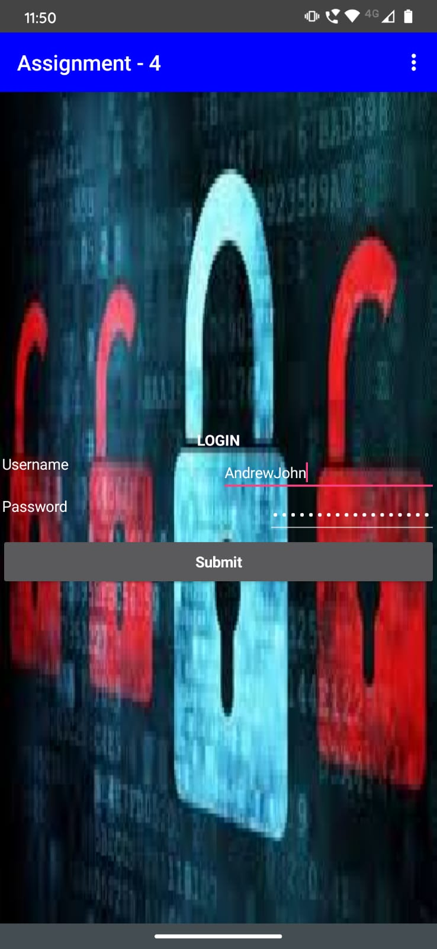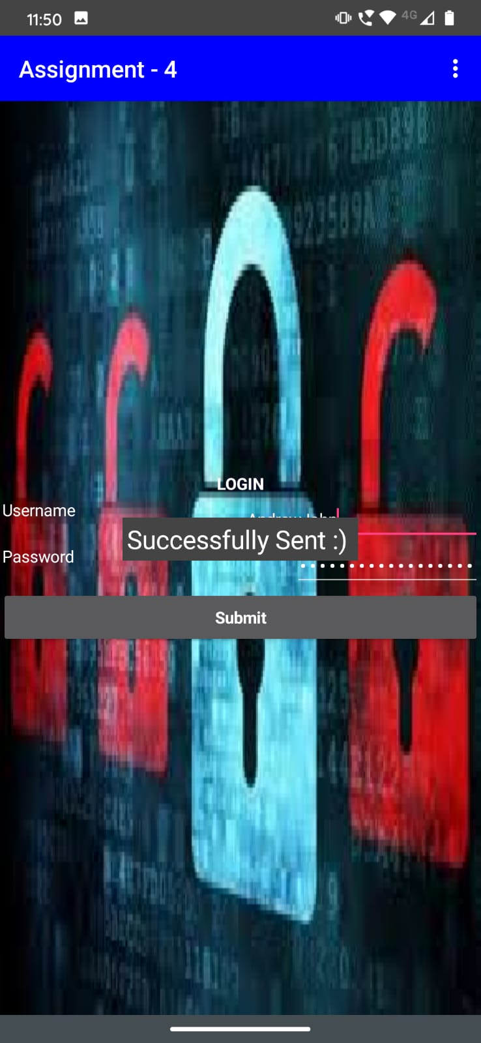

*Fig-7: MIT App Inventor APK App*